Task 1. What do you know?

Purpose: to find out what students already think about the system for their year level and systems in general

Slide | Step | Suggested questions | Student record
Image of slide 2 | - Lead a discussion on what the images might have to do with each other and with earth and space sciences.  (No right or wrong answers, just ask for clarification and points of similarity and differences between answers.) | What might be the common idea in these 3 images?  What have they got to do with earth and space sciences?  How are the ideas you’ve heard the same? How are they different?  What other ideas have you?  What else? | none
Image of slide 3 | - Bring up the idea of systems and discuss what they already know.  (Again this is not a teaching opportunity, just a discussion of different perspectives with no right or wrong) | The curriculum describes them all as systems – what might this mean?  What is a system? How do you recognise them? Why might the idea be useful? | none
Image of slide 4 | - Explain that this task is to find out what they already know about the system their year level will investigate.  - Hand out the sheet and allow 5-10 minutes for them to record their ideas.  - Tell them not to move on to the back of the page until asked. | The system for year 6 the earth’s crust. This task is a chance to show what you already know about it.  If you really don’t know, then say so. If you know a bit, then say what you know. If you aren’t sure, then say so.  You need to record your thinking in as much detail as possible.  The only wrong answers are those which are someone else’s thinking and not yours | Task 1 record sheet  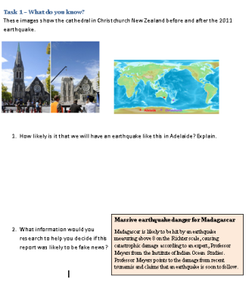
Slide | Step | Suggested questions | Student record
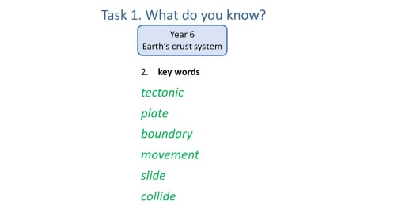  5 | - After students have attempted the task, ask them to turn over their sheets and record on the back. Show the word prompts and explain that they are often used to explain earthquakes. Ask students to explain what these words have to do with earthquakes.  - Give students time to complete the back of the sheet | Here’s a list of words that people might use to do this task. Explain what they have to do with earthquakes. Record this on the back not the front of the sheet. | Task 1 reverse side  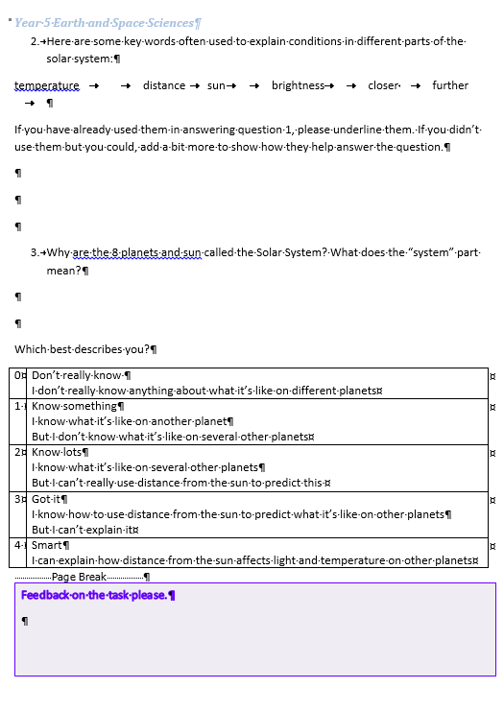

Task feedback:

Task 2. What’s in a name?

Purpose: to provide the language that students will need to engage with this topic
Slide | Step | Suggested questions | Student record
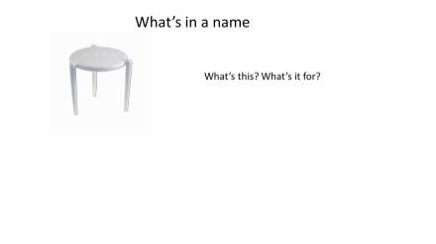  6 | - Show the image and check that they know it’s for keeping the pizza lid off the cheese topping | Where have you seen this before?  What’s it used for? | none
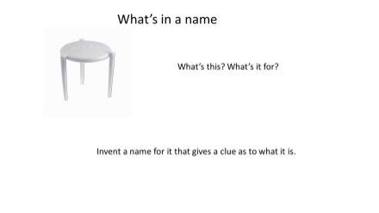  7 | - Tell them that it is known by a variety of names and ask them to invent a name that gives a clue as to what it’s used for.  Share names and establish what gives the clue to its use. | If you had to invent a name for it, what might you call it?  Which of these give a clue as to what it’s used for?
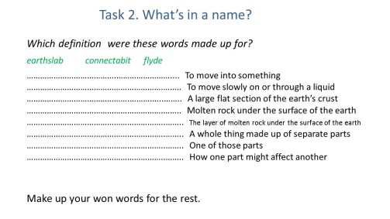  8 | - Show the made up words and ask students to work out which meanings they were made for. How did they work it out?  - Ask students to make up words for the other. A good made up word will give clues to its meaning. | Which meanings were these made up for?  What clues were helpful in working this out?  What names can you come up with for the others?  If you know the name that’s commonly used, invent another one.  Share your words with someone else and see if they can work out the meaning | Task 2 record sheet  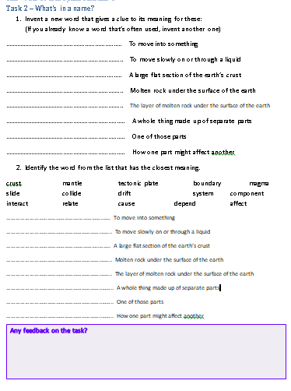
Slide | Step | Suggested questions | Student record
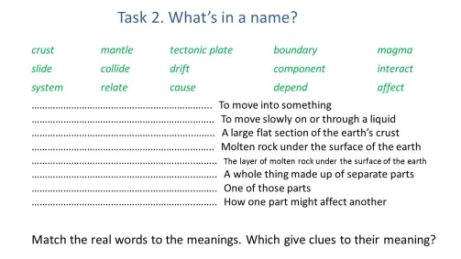  9 | - Ask students to match the real words to the meanings. Discuss any clues that help them do this. | Which of these words can you match? What clues were there to work this out? | Task 2 record sheet

Task feedback:

Task 3. Systems, models and scale

Purpose: students think about systems in general – why we learn about them, where they are useful and how they work

Slide | Step | Suggested questions | Student record
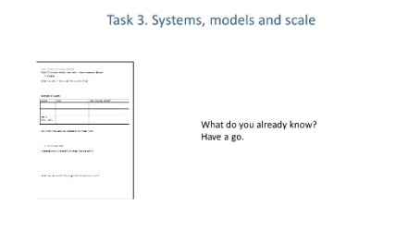  10 | - Explain that to understand how the earth’s crust works as a system, this part looks more closely at systems and how in science we use models to understand them.  - The sheet is for them to record what they already think about systems, models and scale. | Record your thoughts on these. | 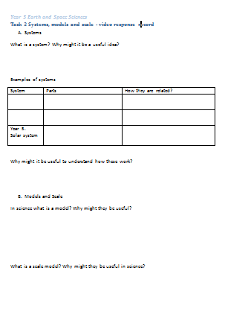  Task 3 record sheet
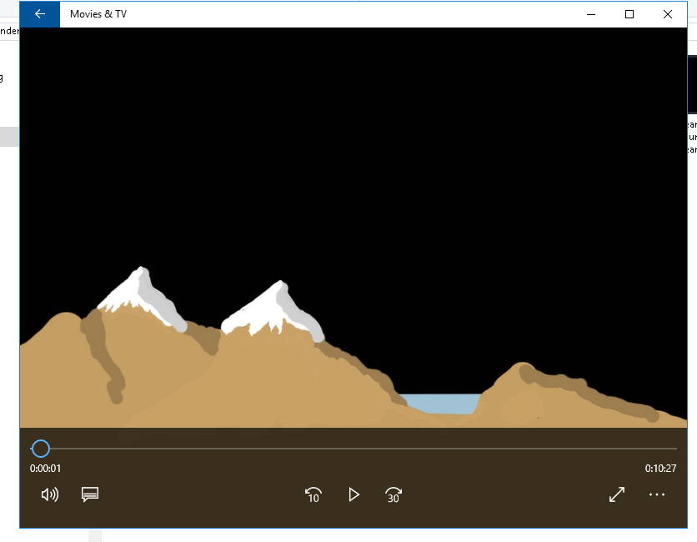  11 | - Show the video
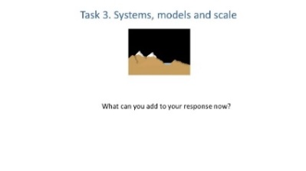  12 | - Ask students to revisit the worksheet and add any other ideas that came out of the video.  You can replay the video or parts of it if needed | What did the video have to say about this?
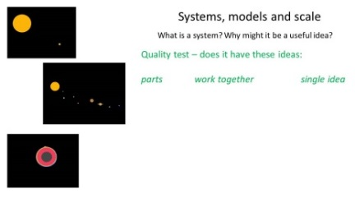  13-16 | - Explain that research shows that feedback can be very effective when students do the assessment themselves  - The green text is a quality test - shows the key ideas for each question. Students should look through their responses and:  - underline anything which is similar or means the same.  - add anything they did not have using a different colour pen or pencil.  Some students need encouragement to do this. | How does your response show this idea? Underline the part that does.  What would you have to add for it to do so? Add this in a different colour pen or pencil.  It is not “wrong” to add stuff you didn’t have here. | Task 3 record sheet
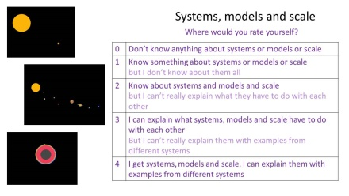  17 | - Show students the learning progression about systems, models and scale and ask them choose a number that best represents their understanding in their view. Ask them to record this number on the top of the sheet with a circle around it. | Which of these is the closest description of your understanding?

Task feedback:

Task 4. DIY model

Purpose: Students experience designing and constructing a model
Slide | Step | Suggested questions | Student record
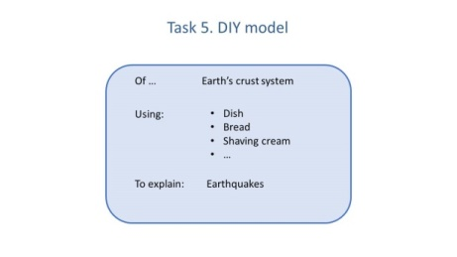  18  You will need for each group of 3:  Year 6  - Bread  - Shaving cream  - Dish | - Explain to students they now get a chance to work with a model. They have been given:  - a system - year 6 the earth’s crust  - some key information about the system on the sheet  - a set of equipment  - what the model needs to explain  - Their task is to construct a model the model and record it either digitally or in diagrams.  - Set a time limit e.g. 30-40 min.  It is more important that students record their attempts at this task than finish it. Enforce the time limit – it doesn’t have to expand to take up huge amounts of time. | What system are you making a model of?  What is it to show?  What equipment do you have? What information do you have?  How is your model like the real thing?  What can it be used to explain or show? | Task 4 record sheet  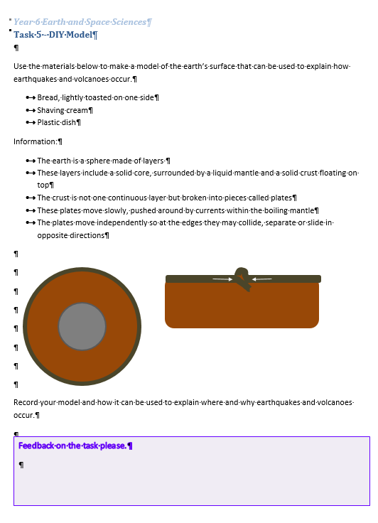

Task feedback:

Task 5. System video

Purpose: Students think about the important parts, relationships and explanations of their system
Slide | Step | Suggested questions | Student record
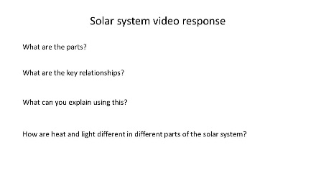  19 | - Ask students to record their ideas on the earth’s crust system using the response sheet. | What are the parts of the earth’s crust system?  What’s the key relationship between them?  What can you explain using this? | Task 5 record sheet  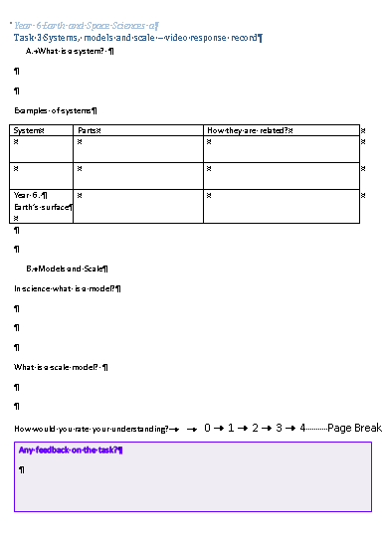
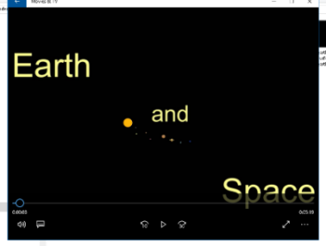  20 | - Show the video  (the challenge question at the end of the video is optional and for students who manage the set work easily)
21 | - Ask students to update their response sheet. | What can you add from the video?
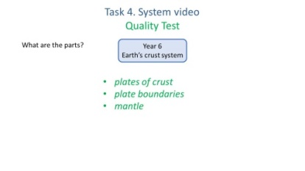  22-24 | Again the green text shows the key ideas for each question.  - Students should look through their responses and underline anything which is similar or means the same. If they did not record it they should add it. | How does your response show this idea? What would you have to add for it to do so? | Task 5 record sheet

Task feedback:

Task 6. Interpret a model

Purpose: students attempt to use their understanding of their systems to interpret a different model

Slide | Step | Suggested questions | Student record
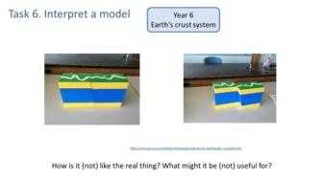  25 | - Tell students that someone has made this model of the real world.  Ask them to think about what the model shows about the real world and what it does not.  - Allow 10-15 minutes for them to record their thoughts on the response sheet. | How is it like the real world?  How is it different?  What would it be useful for? What would it not be useful for? Explain. | 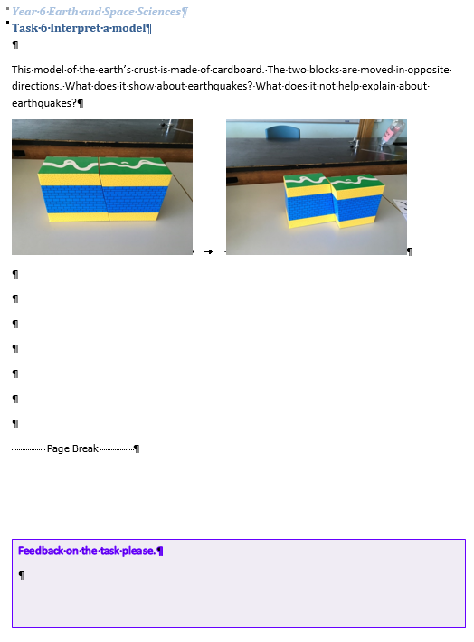
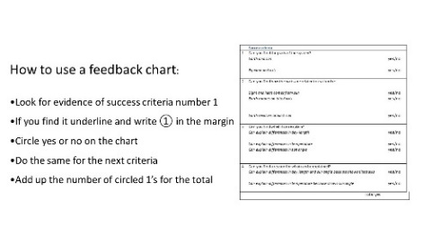 | - Read the instructions for using a feedback chart with students  - Ask them to complete the feedback chart for one or two other students  - Discuss what you can learn from giving and receiving feedback | What did you learn from giving and receiving feedback? | 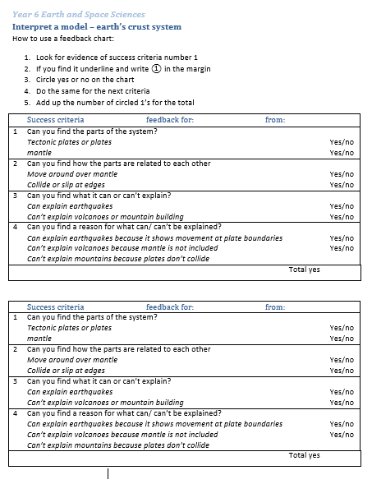

Task feedback:

Task 7. Test drive the system in the real world

Purpose: Students attempt to apply their understanding of their system in a real world context

Slide | Step | Suggested questions | Student record
Image of slide 27 | - Explain to students that here they get a chance to answer the questions about the real world using their understanding of the system involved.  - Allow time for students to discuss their thoughts and then 15-20 minutes to record their responses. | How might what you know about the system we have been looking at help you explain this? | 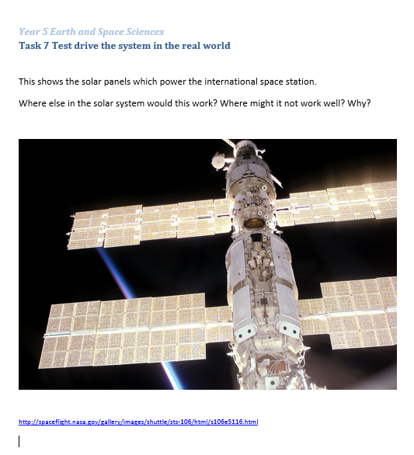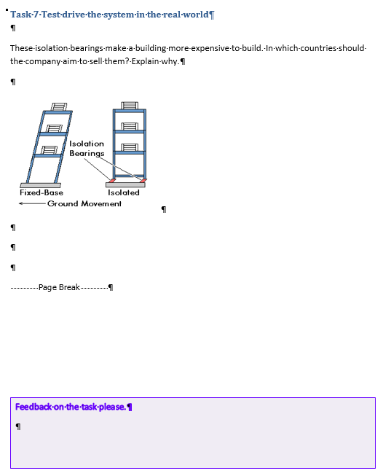  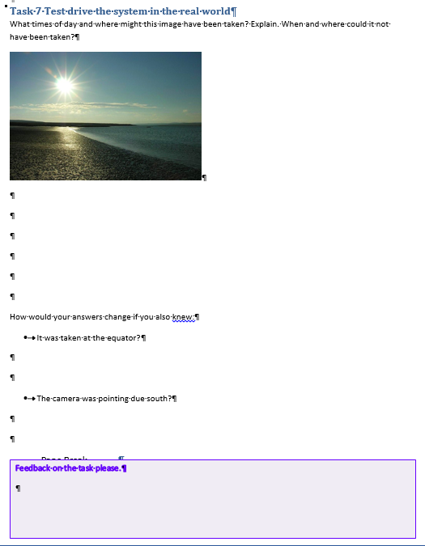
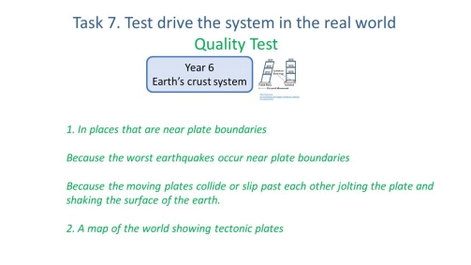  28 | - Ask students to look through their responses and underline anything which is similar or means the same. If they did not record it they should add it.

Task feedback:

Task 8. What do you know?

Purpose: Students repeat the prior knowledge task to demonstrate change in their thinking

Slide | Step | Suggested questions | Student record
Image of slide 29  30 | - Ask students to repeat the prior knowledge task as an opportunity to show how their thinking about systems has changed.  Students are sometimes reluctant to admit that their thinking has changed in any way, but it’s really important that they repeat the task. Do not give them back their first attempt.  Check the instructions for task about completing page 1 before you release the key words. | You may remember doing this task earlier on, but here is an opportunity to show how your thinking has changed. | Task 1 record sheet  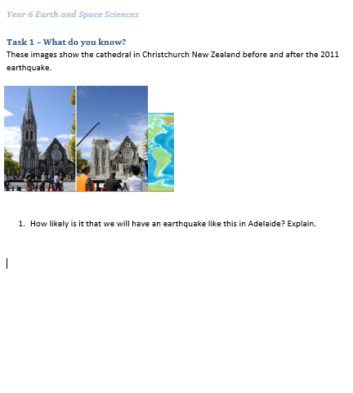  Task 1 reverse side

Task feedback:

Task 9. Expanding the system

Purpose: students consider extra parts or ideas in their system

Slide | Step | Suggested questions | Student record
Image of slide 31 | - Tell students that so far we have focused on a small part of the system. In this task they will need to think about how it might work if they add some more parts to the system.  All the information they need is provided on the sheet. This is not a research task - it’s about thinking about how this information fits into the system they have already worked on. No access to internet or other resources is to be used.  - Read through the sheet with them before allowing about 30 minutes for them to work on it. Students may discuss with others but should record individually. | What do you already know about this system?  What extra parts or ideas have been included?  How might you put what you already know together with the extra information to explain?  How might you get started on this?  It’s not about researching extra information – it’s about using what has been given | Task 9 record sheet  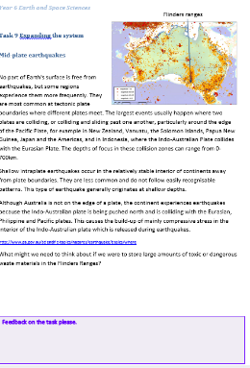

Task feedback:

Task 10. The tide system

Purpose: Students attempt to work with a new system

Slide | Step | Suggested questions | Student record
Image of slide 32 | - Tell students that this is an opportunity to think about something new.  - Explain that the images show the difference between high and low tide at the same place. Ask students to briefly share their experience of tides.  - Look at the graph and establish the difference between the high and low tides that happen twice a day (the 30 individual peaks and troughs) and the Spring and Neap tides that happen twice a month (the two bulges and constrictions made by the overall graph).  - Point out that the two diagrams show an explanation for this. Ask them to look carefully at how the two diagrams are the same and different and then produce an explanation to go with them on how tides work. This is not a research task. They need to use their own thoughts and ideas.  - Allow about 10-15 minutes for students to start this. They may discuss it with others but should record their thoughts individually on the front of the sheet. | How might you get started on this?  What do you already know that might help?  What extra information has been given?  How might you put them together?  This is a challenging task. What can you do with it? | Task 10 record sheet  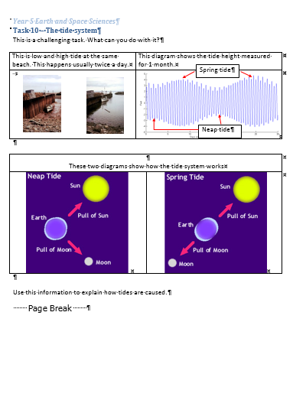
Image of slide 33 | - After 10-15 min, ask students to mark the last line they have written with and asterisk in the margin.  - Show the slide with the systems prompts and ask how they might be useful in the task. Ask students to turn over and respond to the questions on the back of the sheet | How would it look if you were to see this as a system, and look for parts and relationships between them?  Would it help you go some way to explaining tides? | Task 10 reverse side  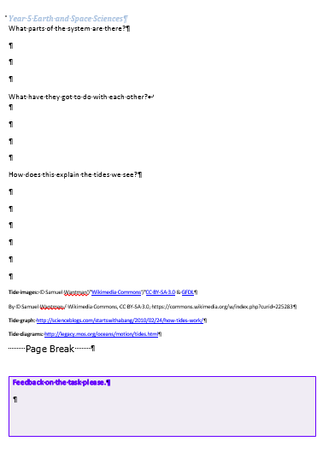

Task feedback:

Task 11. The movie advisor

Purpose; Students use learning in a different context

Slide | Step | Suggested questions | Student record
Image of slide 34 | - Explain to students that this task involves them using what science they know to construct a short information report (called a brief)  - This is not a research task. They can discuss it with others, but need to record independently.  - Allow 5 min discussion time and then about 20 minutes to record in writing. | What is the important science thinking about this?  How can you explain it so that the other film people will be able to use it in their work? | Task 11 record sheet  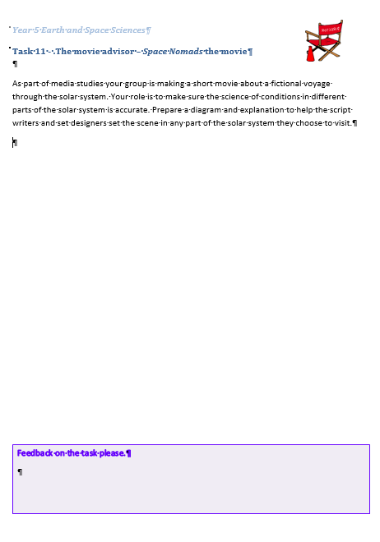

Task feedback:

