Fire Extinguishers
Image of water sprayed on a fire | Image of CO2 sprayed on a fire | Image of powder sprayed on a fire | Image of foam sprayed on a fire | Image of a fire blanket being placed over a stove
Water | CO₂ | Powder | Foam | Fire blanket
What do you think will happen to the different materials after the fire has been put out?
What do you think about the different materials?
What do you notice about the different fire extinguishers?

What do you know?
What do you think you will be learning about in this topic?

What do you already know about it?

Why is it important?

What do you think you will be doing in science lessons to learn this?

A. Solids, liquids and gases video questions
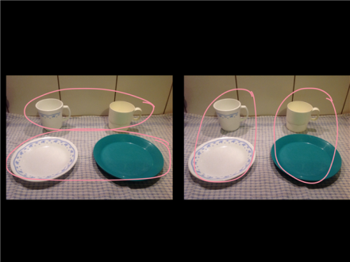 | 1. Which focuses on the materials rather than the objects? Explain.
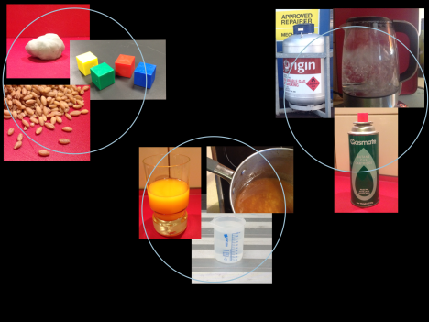 | 2. What is the difference between solids, liquids and gases
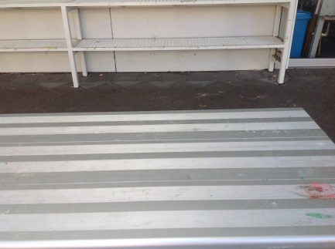 | 3. What would you need to keep these on a table?  - Solid  - Liquid  - Gas?
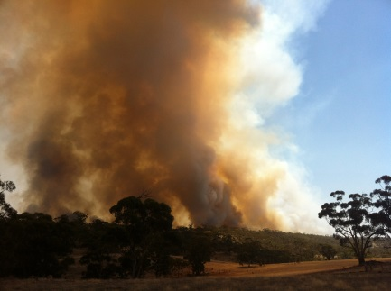 | 4. How would you classify smoke? Explain.
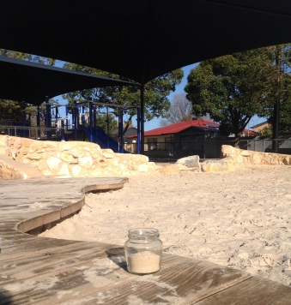  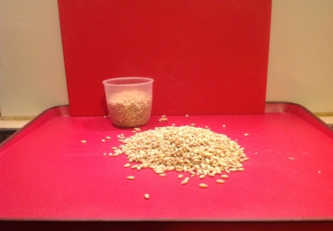 | 5. How would you classify sand and seed? Explain.

Solids, liquids and gases – the important stuff

All solids are the same because …

but they are different because …

All liquids are the same because …

but they are different because …

All gases are the same because …

but they are different because …

What are the important differences between solids, liquids and gases?

Classifying materials
Material | Solid/ liquid/ gas | How do you know?

Classifying materials
Material | Solid/ liquid/ gas | How do you know?

Can something belong to more than one group? Explain.

Classifying in action

Jet trails
How would you classify jet trails? Explain. What information would help?
Image of jet trails

Mystery bottle.
Image of a bottle labelled “liquid”

What do you know about the contents of the bottle?

What don’t you know?

Without opening the bottle, what could you do to get more information? Explain.

Making honeycomb

What solids, liquids and gases did you notice? Explain.

Solids, liquids and gas drama

Instructions:

Solid:
- Link elbows
- Rock gently to and fro on the spot

Liquid:
- Hold each other’s hands loosely
- stay within 1m of the front wall of the room
- move about independently as much as you can without letting go of hands

Gas
- ignore the other actors
- walk about the room, covering as many spaces as you can
- if you bump into someone or something gently reverse direction

- How were the 3 dramas like solids, liquids and gases?

- How were they not like them?

- How else could you represent solids, liquids and gases? Explain.

How did you go?
What did you learn in this topic?

Why is it important? When might you use it?

What helped you learn?

Any other feedback?

Drama cards

Solid | Solid | Solid
- Link elbows  - Rock gently to and fro on the spot | - Link elbows  - Rock gently to and fro on the spot | - Link elbows  - Rock gently to and fro on the spot

Liquid | Liquid | Liquid
- Hold each other’s hands loosely  - stay within 1m of the front wall of the room  - move about independently as much as you can without letting go of hands | - Hold each other’s hands loosely  - stay within 1m of the front wall of the room  - move about independently as much as you can without letting go of hands | - Hold each other’s hands loosely  - stay within 1m of the front wall of the room  - move about independently as much as you can without letting go of hands

Gas | Gas | Gas
- ignore the other actors  - walk about the room, covering as many spaces as you can  - if you bump into someone or something gently reverse direction | - ignore the other actors  - walk about the room, covering as many spaces as you can  - if you bump into someone or something gently reverse direction | - ignore the other actors  - walk about the room, covering as many spaces as you can  - if you bump into someone or something gently reverse direction

