Fire Extinguishers
Image of water sprayed on a fire | Image of CO2 sprayed on a fire | Image of powder sprayed on a fire | Image of foam sprayed on a fire | Image of a fire blanket being placed over a stove
Water | CO₂ | Powder | Foam | Fire blanket
What do you think will happen to the different materials after the fire has been put out?
What do you think about the different materials?
What do you notice about the different fire extinguishers?

What do you know?
What do you think you will be learning about in this topic?

What do you already know about it?

Why is it important?

What do you think you will be doing in science lessons to learn this?

C. Classifying materials video questions
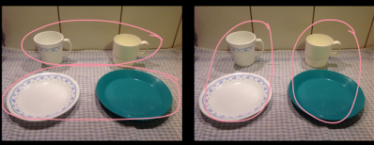 | 1. How have they been classified? What’s the difference between the two ways? When else might people classify like this?
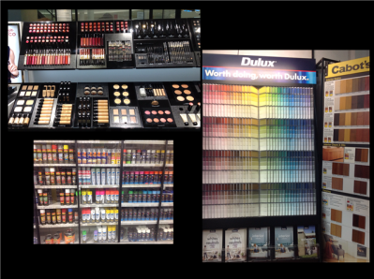 | 2. How have they been sorted? Who might find this useful? What else can be classified like this?
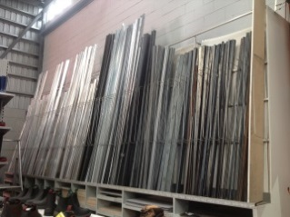  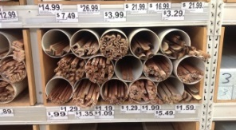 | 2. How have they been sorted? Who might find this useful? What else can be classified like this?
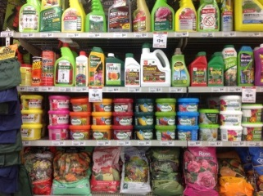 | 2 How have they been sorted? Who might find this useful? What else can be classified like this?
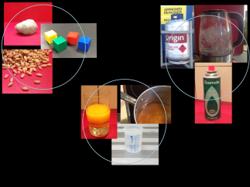 | 3. What similarities are there in each group? How do the groups differ? What does this mean for storing, moving and mixing them?
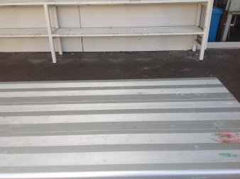 | 4. What would you need to keep these on a table?  Solid  Liquid  Gas
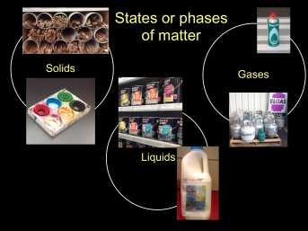 | 5. When might it be useful to classify as solids liquids and gases?
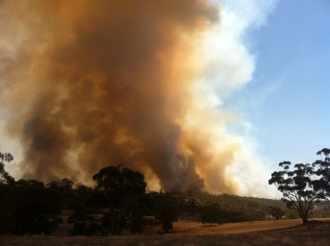 | 6. How would you classify smoke? Explain.

Solids, liquids and gases – the important stuff

All solids are the same because …

but they are different because …

All liquids are the same because …

but they are different because …

All gases are the same because …

but they are different because …

What are the important differences between solids, liquids and gases?

Classifying materials
Group | Contains | Because they all
A
B
C
D
E
F
G
H
I

Classifying materials
Group | Contains | Because they all
solids
liquids
gases
Don’t know

Can something belong to more than one group? Explain.

Classifying in action

Jet trails
How would you classify jet trails? Explain. What information would help?
Image of jet trails

Mystery bottle.
L
Image of a bottle labelled “liquid”
What do you know about the contents of the bottle?

What don’t you know?

Without opening the bottle, what could you do to get more information? Explain.

More
What solids, liquids and gases did you notice? Explain
Volcanoes
Making honeycomb
Water isn’t water?
.

What comes out of a Volcano?
Images of products of volcanoes |  | Pyroclastic flow – mixture of small rock pieces and hot poisonous gases | Lava - molten rock
Ash – tiny pieces of glass and rock less than 2mm. | Sulphur dioxide and other poisonous gases | Lava bombs – pieces of rock larger than 6cm | Lahar – mixture of water and rock pieces

http://www.geology.sdsu.edu/how_volcanoes_work/Products.html http://www.express.co.uk/news/nature/527590/Japan-volcano-Mount-Ontake

Making honeycomb

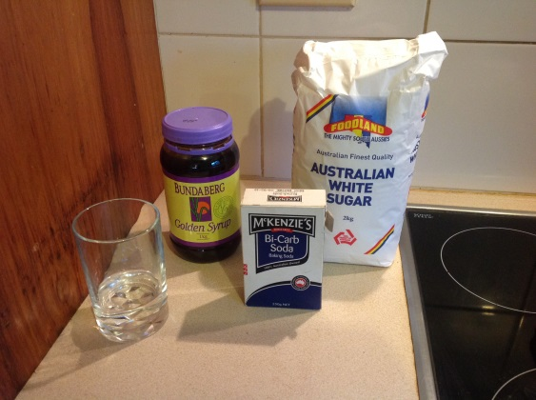 | 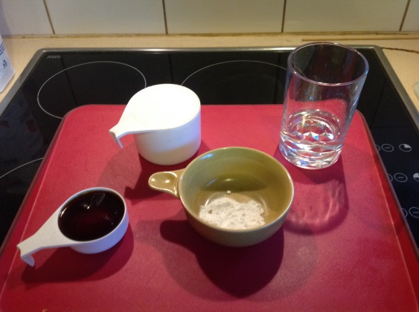 | 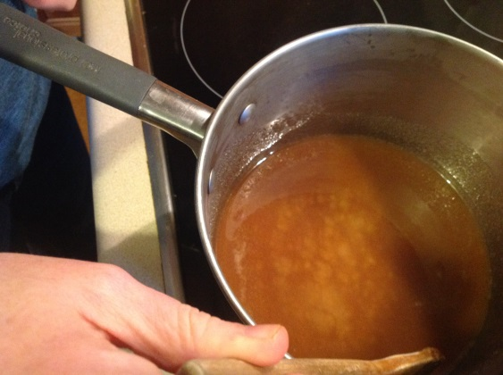 | 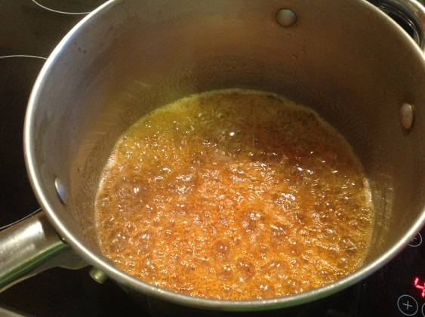
You need: water, golden syrup, bicarb soda and sugar | Measure | Mix water, golden syrup and bicarb | Heat until bubbles
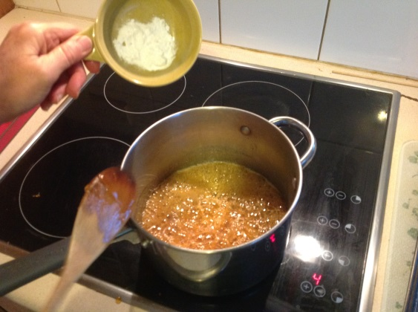 | 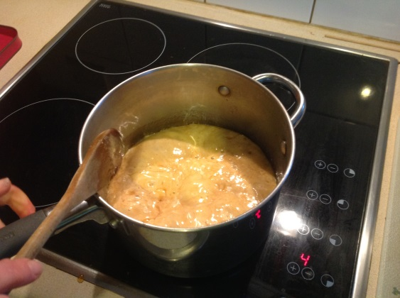 | 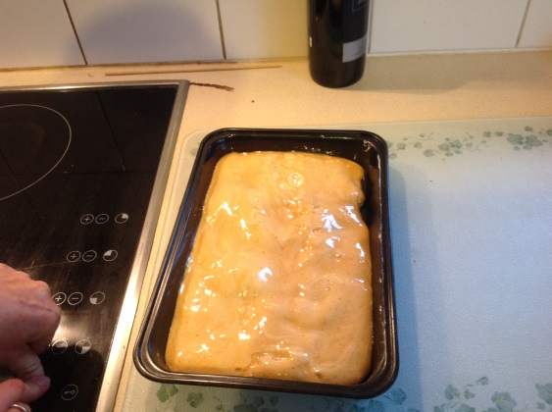 | 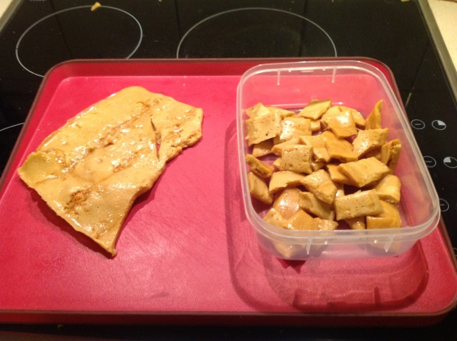
Add bicarb | Mixture froths up | Pour into tray | Cut into pieces when set

Solids, liquids and gas drama

Instructions:

Group A
- Link elbows
- Rock gently to and fro on the spot

Group B
- Hold each other’s hands loosely
- stay within 1m of the front wall of the room
- move about independently as much as you can without letting go of hands

Group C
- ignore the other actors
- walk about the room, covering as many spaces as you can
- if you bump into someone or something gently reverse direction

- How were the 3 dramas like solids, liquids and gases?

- How were they not like them?

- How else could you represent solids, liquids and gases? Explain.

How did you go?
What did you learn in this topic?

Why is it important? When might you use it?

What helped you learn?

Any other feedback?

Drama cards

Group A | Group A | Group A
- Link elbows  - Rock gently to and fro on the spot | - Link elbows  - Rock gently to and fro on the spot | - Link elbows  - Rock gently to and fro on the spot

Group B | Group B | Group B
- Hold each other’s hands loosely  - stay within 1m of the front wall of the room  - move about independently as much as you can without letting go of hands | - Hold each other’s hands loosely  - stay within 1m of the front wall of the room  - move about independently as much as you can without letting go of hands | - Hold each other’s hands loosely  - stay within 1m of the front wall of the room  - move about independently as much as you can without letting go of hands

Group C | Group C | Group C
- ignore the other actors  - walk about the room, covering as many spaces as you can  - if you bump into someone or something gently reverse direction | - ignore the other actors  - walk about the room, covering as many spaces as you can  - if you bump into someone or something gently reverse direction | - ignore the other actors  - walk about the room, covering as many spaces as you can  - if you bump into someone or something gently reverse direction

