Task 1 – What do you know?
These images show the cathedral in Christchurch New Zealand before and after the 2011 earthquake.

Image of Christchurch cathedral before and after earthquake
Map of the world showing Adelaide and Christchurch

- How likely is it that we will have an earthquake like this in Adelaide? Explain.

Massive earthquake danger for Madagascar
Madagascar is likely to be hit by an earthquake measuring above 8 on the Richter scale, causing catastrophic damage according to an expert, Professor Meyers from the Institute of Indian Ocean Studies. Professor Meyers points to the damage from recent tsunamis and claims that an earthquake is soon to follow.
- What information would you research to help you decide if this report was likely to be fake news?

- Here are some key words often used to explain where earthquakes occur:
tectonic plate boundary movement slide collide
Explain how they help answer questions 1 and 2

- What does it mean when people talk about the earth’s crust as part of a system?

Which best describes you?
0 | Don’t really know  I don’t really know anything about where earthquakes happen
1 | Know something  I know something about tectonic plates or where earthquakes happen  But I don’t know about both
2 | Know lots  I know about tectonic plates and where earthquakes happen  But I don’t really get how movement of tectonic plates explains earthquakes and volcanoes
3 | Got it  I know how movement of tectonic plates explains earthquakes and volcanoes  But I can’t use movement of tectonic plates to predict where earthquakes and volcanoes might occur
4 | Smart  I can use movement of tectonic plates to predict where earthquakes and volcanoes might and might not occur
Any feedback on the task?

Task 2 – What’s in a name?
- Invent a new word that gives a clue to its meaning for these:
(If you already know a word that’s often used, invent another one)
………………………………………….……………..….. To move into something
……………………………………………………….…….. To move slowly on or through a liquid
……………………………………….……………..…….. A large flat section of the earth’s crust
……………………………………………………….…….. Molten rock under the surface of the earth
……………………………………………………….…….. The layer of molten rock under the surface of the earth
………………………………………………………..…….. A whole thing made up of separate parts
………………………………………………………..…….. One of those parts
………………………………………………………..…….. How one part might affect another
crust mantle tectonic plate boundary magma
slide collide drift system component
interact relate cause depend affect
- Identify the word from the list that has the closest meaning.
………………………………………….……………..….. To move into something
……………………………………………………….…….. To move slowly on or through a liquid
……………………………………….……………..…….. A large flat section of the earth’s crust
……………………………………………………….…….. Molten rock under the surface of the earth
……………………………………………………….…….. The layer of molten rock under the surface of the earth
………………………………………………………..…….. A whole thing made up of separate parts
………………………………………………………..…….. One of those parts
………………………………………………………..…….. How one part might affect another
Any feedback on the task?

Task 3 Systems, models and scale - video response record

Systems
What is a system? Why might it be a useful idea?

Can you think of some examples of systems?
System | Parts | How they are related?
Year 6.
Earth’s surface

Why might it be useful to understand how these work?

Models and Scale
In science what is a model? Why might they be useful?

What is a scale model?

How would you rate your understanding? 0 1 2 3 4
Low high
Any feedback on the task?

Task 4 - DIY Model The earth’s crust

Use the materials below to make a model of the earth’s surface that can be used to explain how earthquakes and volcanoes occur.
- Bread
- Shaving cream
- Plastic dish
Information:
- The earth is a sphere made of layers
- These layers include a solid core, surrounded by a liquid mantle and a solid crust floating on top
- The crust is not one continuous layer but broken into pieces called plates
- These plates move slowly, pushed around by currents within the boiling mantle
- The plates move independently so at the edges they may collide, separate or slide in opposite directions

Make a photo or diagram to record.
How does this explain how earthquakes occur? (record on the back of this sheet)

Any feedback on the task?

Task 5 System video response

- What are the parts of the earth’s crust system?

- What are the key relationships between them?

- What could you use this to explain?
Any feedback on the task?

Task 6 Interpret a model
What might this model of the earth’s crust be made of?
What has been changed in the second image? What is it trying to show?

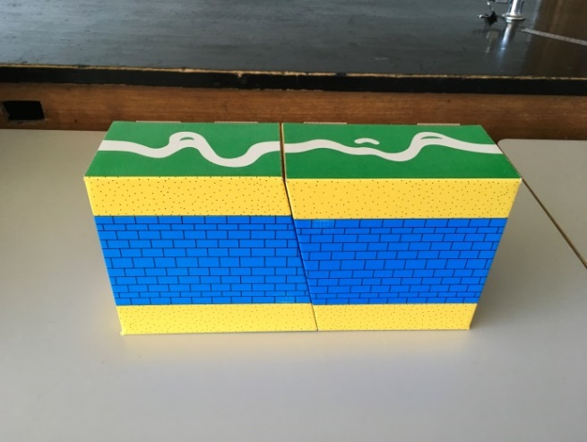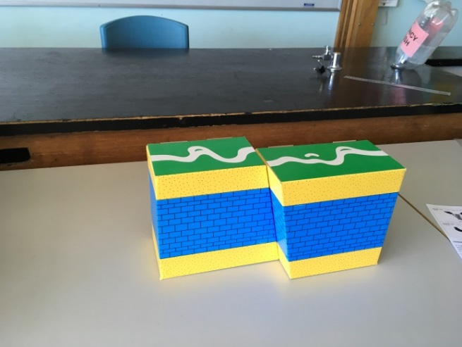
- How is this model of the earth’s crust like the real thing?

- What might it be useful to explain?

- What is it not useful to explain? Why (not)? How could it be improved?

Any feedback on the task?

Interpret a model – earth’s crust system
How to use a feedback chart:
- Look for evidence of success criteria number 1
- If you find it underline and write ① in the margin
- Circle yes or no on the chart
- Do the same for the next criteria
- Add up the number of circled 1’s for the total
 | Success criteria feedback for: from:
1 | Can you find the parts of the system?
 | Tectonic plates or plates | Yes/no
 | Plate boundaries or edges | Yes/no
 | Mantle | Yes/no
2 | Can you find how the parts are related to each other
 | Move around over mantle | Yes/no
 | Collide or slip at edges | Yes/no
3 | Can you find what it can or can’t explain?
 | Can explain earthquakes | Yes/no
 | Can’t explain where earthquakes occur in the world | Yes/no
4 | Can you find a reason for what can/ can’t be explained?
 | Can explain earthquakes because it shows movement at plate boundaries | Yes/no
 | Can’t explain where earthquakes occur because it’s only a small part of two plates | Yes/no
 | Total yes

 | Success criteria feedback for: from:
1 | Can you find the parts of the system?
 | Tectonic plates or plates | Yes/no
 | Plate boundaries or edges | Yes/no
 | Mantle | Yes/no
2 | Can you find how the parts are related to each other
 | Move around over mantle | Yes/no
 | Collide or slip at edges | Yes/no
3 | Can you find what it can or can’t explain?
 | Can explain earthquakes | Yes/no
 | Can’t explain where earthquakes occur in the world | Yes/no
4 | Can you find a reason for what can/ can’t be explained?
 | Can explain earthquakes because it shows movement at plate boundaries | Yes/no
 | Can’t explain where earthquakes occur because it’s only a small part of two plates | Yes/no
 | Total yes

Task 7 Test drive the system in the real world
Diagram of isolation bearings in a high rise building
These isolation bearings make a building more expensive to build.
- In which countries should the company aim to sell them? Explain why.

- What information do you need to answer this question? How could you find it?

Any feedback on the task?

Flinders ranges

Task 9 Expanding the system
Figure 1 Earthquakes in Australia

Mid-plate earthquakes
Map of Australia showing distribution of earthquakes

No part of Earth's surface is free from earthquakes, but some regions experience them more frequently. They are most common at tectonic plate boundaries where different plates meet. The largest events usually happen where two plates are colliding, or colliding and sliding past one another, particularly around the edge of the Pacific Plate, for example in New Zealand, Vanuatu, the Solomon Islands, Papua New Guinea, Japan and the Americas, and in Indonesia, where the Indo-Australian Plate collides with the Eurasian Plate. The depths of focus in these collision zones can range from 0-700km.
Shallow intraplate earthquakes occur in the relatively stable interior of continents away from plate boundaries. They are less common and do not follow easily recognisable patterns. This type of earthquake generally originates at shallow depths.
Although Australia is not on the edge of a plate, the continent experiences earthquakes because the Indo-Australian plate is being pushed north and is colliding with the Eurasian, Philippine and Pacific plates. This causes the build-up of mainly compressive stress in the interior of the Indo-Australian plate which is released during earthquakes.
http://www.ga.gov.au/scientific-topics/hazards/earthquake/basics/where
The Flinders Ranges have been suggested as a place to store toxic or dangerous waste. How might what we know about the earth’s crust be useful here? Explain. (use the back of the sheet)
Any feedback on the task?

Task 10 – The tide system
This is a challenging task. What can you do with it?
This is low and high tide at the same beach. This happens usually twice a day. | This diagram shows the tide height measured for 1 month.
Images of jetty at high and low tide | Chart of tide heights for a month  Neap tide

These two diagrams show how the tide system works
Diagram showing position of earth, sun and moon at neap and spring tides

Use this information to explain how tides are caused.

What parts of the system are there?

What have they got to do with each other?

How does this explain the tides we see?

Tide images: © Samuel Wantman / Wikimedia Commons / CC BY-SA 3.0 & GFDL
By © Samuel Wantman / Wikimedia Commons, CC BY-SA 3.0, https://commons.wikimedia.org/w/index.php?curid=225283
Tide graph: http://scienceblogs.com/startswithabang/2010/02/24/how-tides-work/
Tide diagrams: http://legacy.mos.org/oceans/motion/tides.html
Any feedback on the task?

Task 11 - The movie advisor – Quake 10 the movie
Clipart of director’s chair
Any feedback on the task?

As part of media studies your group is making a short movie about how people survived an earthquake disaster. Your role is to make sure the science of earthquakes is accurate. Prepare a diagram and explanation to help the script writers and set designers set the scene for the earthquake.

