Supplementary Information 4: Subsampling
Below are the results generated using the subsampling script. These data demonstrate how standard deviation decreases as the sample size in increased. At the top of each figure is the data for the two species considered undifferentiated by interspecific factors. Below that is the same estimates when data are controlled by intraspecific factor.
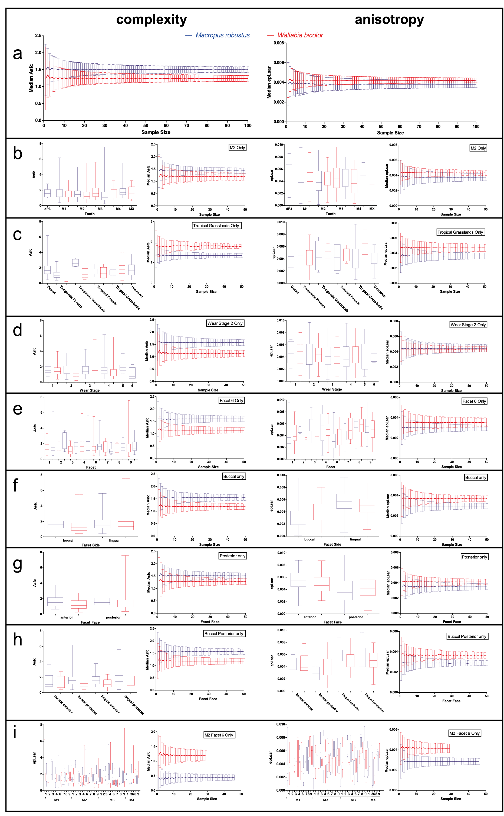
Figure SI 4.1: Subsampling and SSFA variables; Asfc or complexity (left) and epLsar or anisotropy (right) for Macropus robustus (blue) and Wallabia bicolor (red). Box plots demonstrate how data vary for each factor and corresponding graph of mean and standard deviation of bootstrapped samples demonstrates sample size required to differentiate taxa when controlled for that factor. ‘A’ is all the same sample size comparison for all data undifferentiated by any factor, ‘b’ separates species by tooth, ‘c’ by ecoregion, ‘d’ by wear stage, ‘e’ by facet, ‘f’ by facet side, ‘g’ by facet face, ‘h’ by facet side + face, and ‘i’ is the commonly used sampling protocol of controlling for element, tooth and facet. Note that for this panel boxplots do not contain dp3 or mx (tooth unknown) for simplicity.
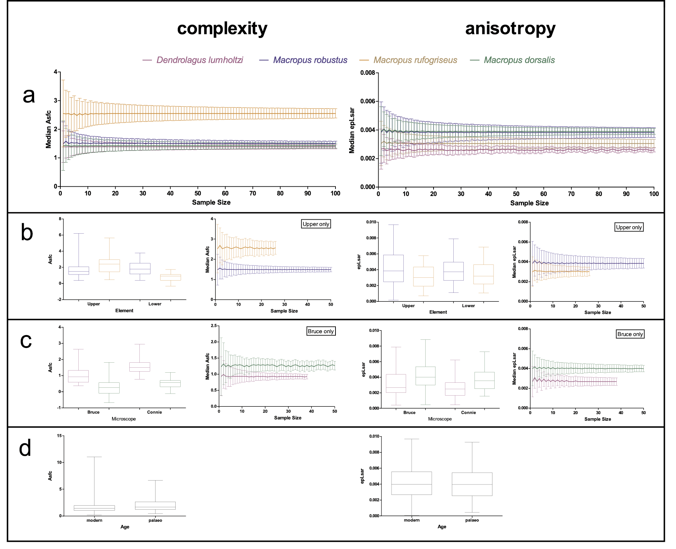
Figure 4.2: Subsampling and SSFA variables; Asfc or complexity (left) and epLsar or anisotropy (right) for Dendrolagus lumholtzi (purple), Macropus dorsalis (brown), M. robustus (blue) and M. rufogriseus (green). Box plots demonstrate how data vary for each factor and corresponding graph of mean and standard deviation of bootstrapped samples demonstrates sample size required to differentiate taxa when controlled for that factor. ‘a’ is all the same sample size comparison for all data undifferentiated by any factor, ‘b’ separates each species by element, ‘c’ by microscope, and ‘d’ by age (unavailable within species).

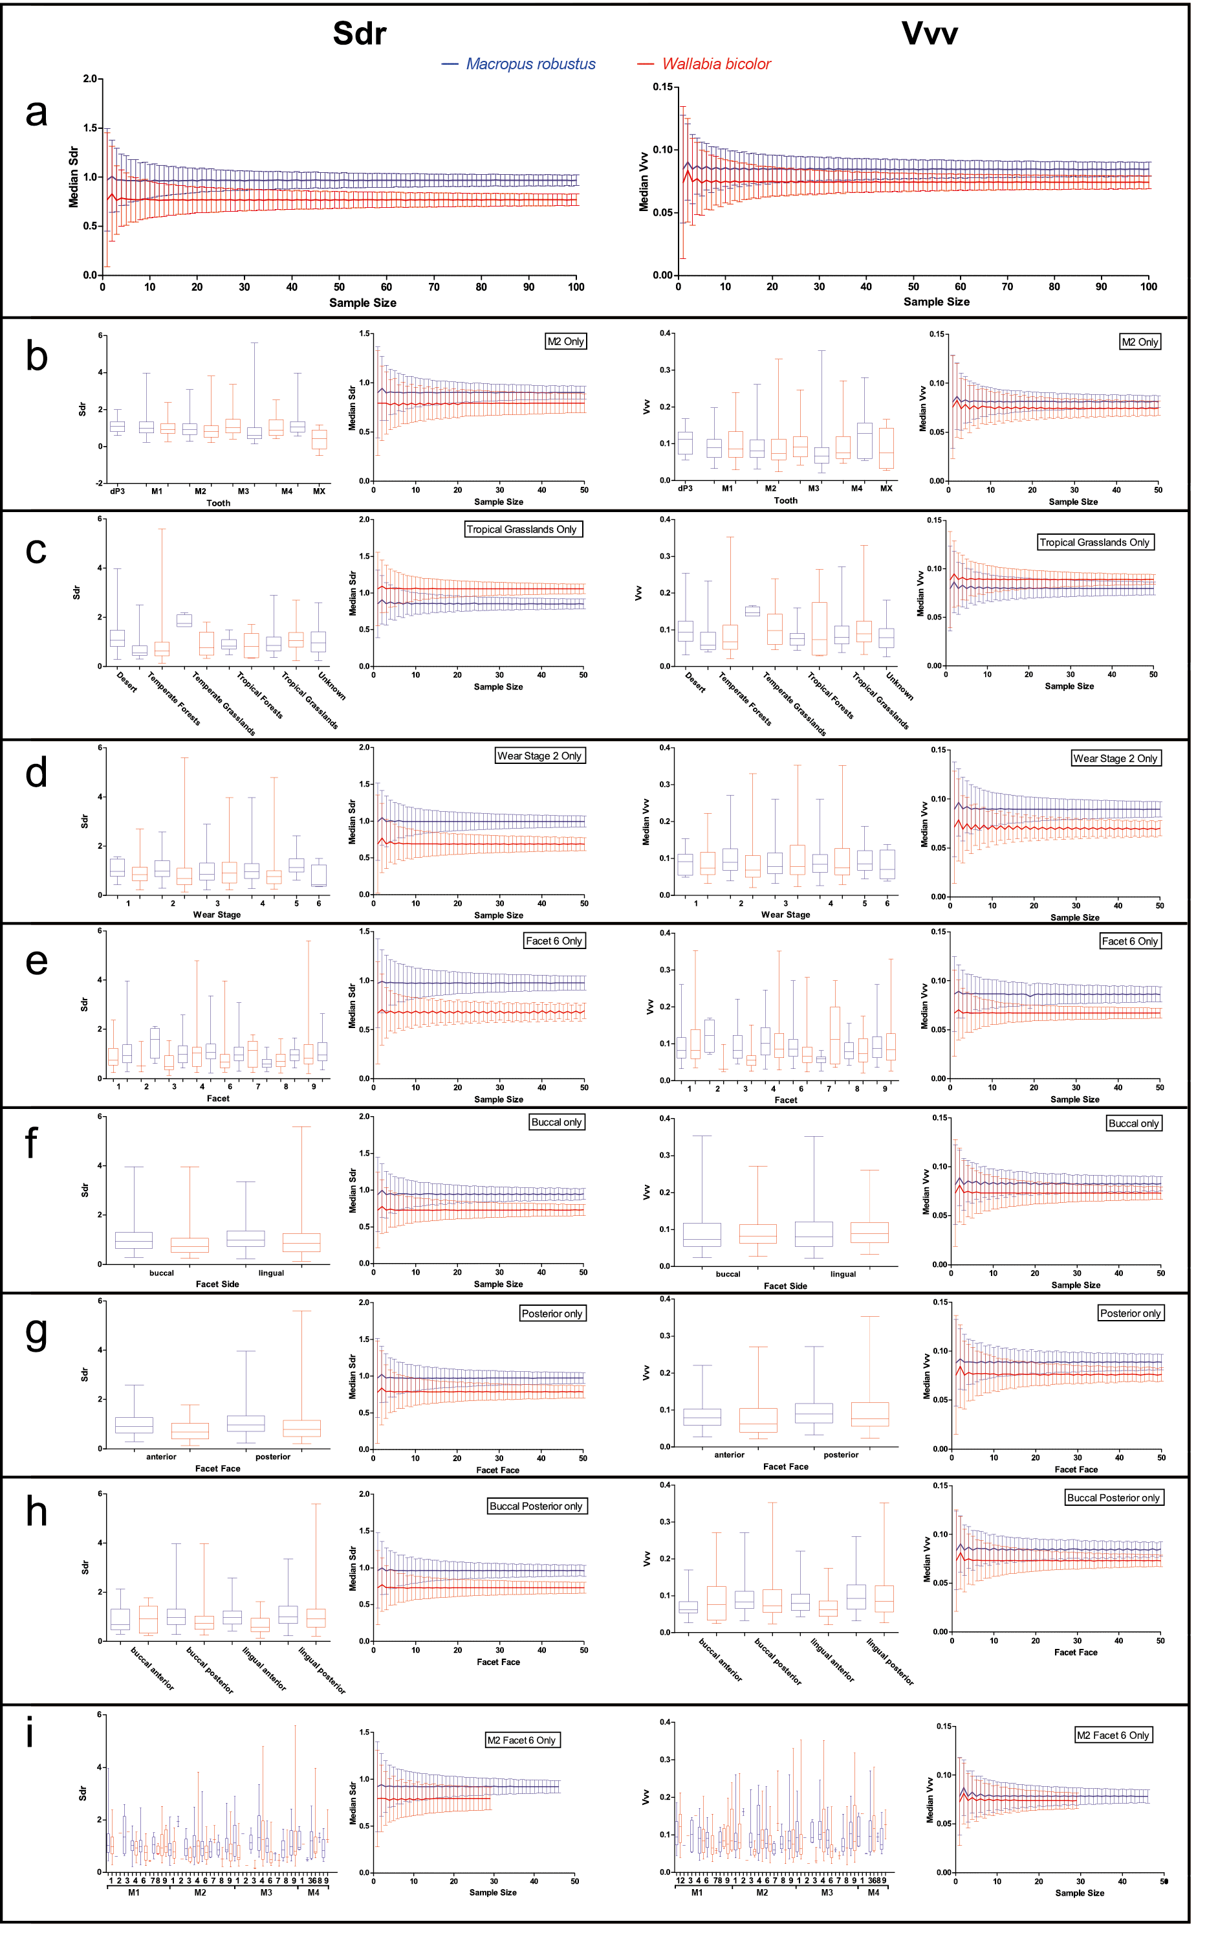
Figure SI 4.3: Subsampling and STA variables; developed interfacial area ratio (Sdr, left) and void volume of the valleys (Vvv) at a material ratio of 80% (right), for Macropus robustus (blue) and Wallabia bicolor (red). Box plots demonstrate how data vary for each factor and corresponding graph of mean and standard deviation of bootstrapped samples demonstrates sample size required to differentiate taxa when controlled for that factor. ‘A’ is all the same sample size comparison for all data undifferentiated by any factor, ‘b’ separates species by tooth, ‘c’ by ecoregion, ‘d’ by wear stage, ‘e’ by facet, ‘f’ by facet side, ‘g’ by facet face, ‘h’ by facet side + face, and ‘g’ is the commonly used sampling protocol of controlling for element, tooth and facet. Note that for this panel boxplots do not contain dp3 or mx (tooth unknown) for simplicity.
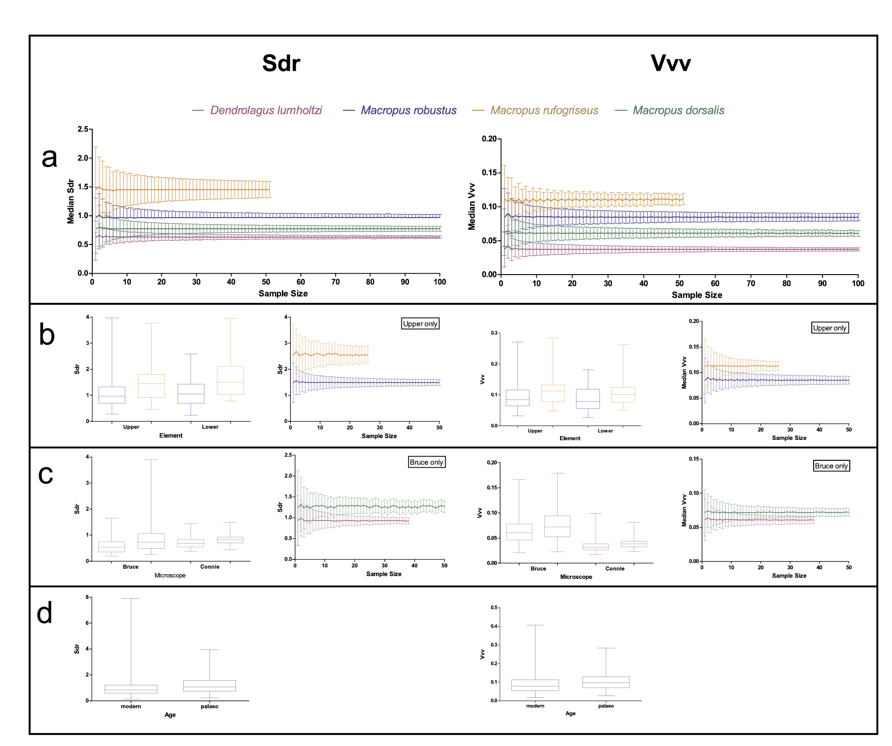
Figure SI 4.4: Subsampling and STA variables; developed interfacial area ratio (Sdr, left) and void volume of the valleys (Vvv) at a material ratio of 80% (right), for Dendrolagus lumholtzi (purple), Macropus dorsalis (brown), M. robustus (blue) and M. rufogriseus (green). Box plots demonstrate how data vary for each factor and corresponding graph of mean and standard deviation of bootstrapped samples demonstrates sample size required to differentiate taxa when controlled for that factor. ‘a’ is all the same sample size comparison for all data undifferentiated by any factor, ‘b’ separates each species by element, ‘c’ by microscope, and ‘d’ by age (unavailable within species).

